Phase 1: Initial Data Exploration Report
Project: Detection of AI-Generated Arabic Text
Comprehensive analysis of "KFUPM-JRCAI/arabic-generated-abstracts" dataset.
--------------------------------------------------

1. Overview of Dataset Splits

Row Counts Summary
Dataset Split | Number of Rows
by_polishing | 2851
from_title | 2963
from_title_and_content | 2574
Total | 8388

Visualization: Row Distribution
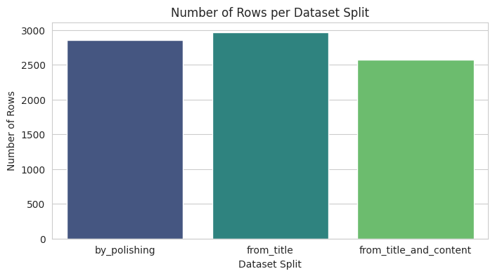

Analysis of Split: by_polishing

Dataset Structure (Columns)
Column Name | Data Type
original_abstract | Value('string')
allam_generated_abstract | Value('string')
jais_generated_abstract | Value('string')
llama_generated_abstract | Value('string')
openai_generated_abstract | Value('string')

Target Variable Distribution
Class | Count | Percentage
Human-written | 2851 | 20.0%
AI-generated | 11404 | 80.0%

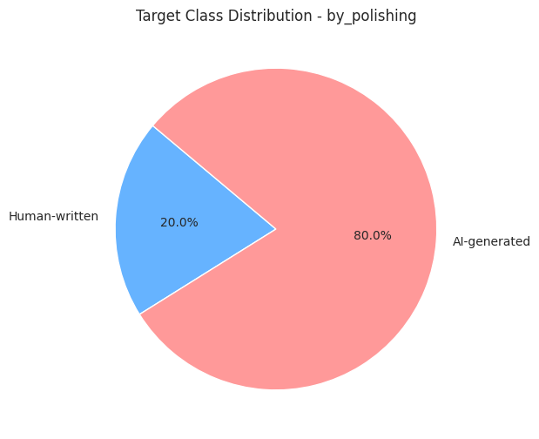

No missing values detected in this split.

Duplicates Analysis
Column | Duplicate Entries
original_abstract | 0
allam_generated_abstract | 0
jais_generated_abstract | 0
llama_generated_abstract | 0
openai_generated_abstract | 0

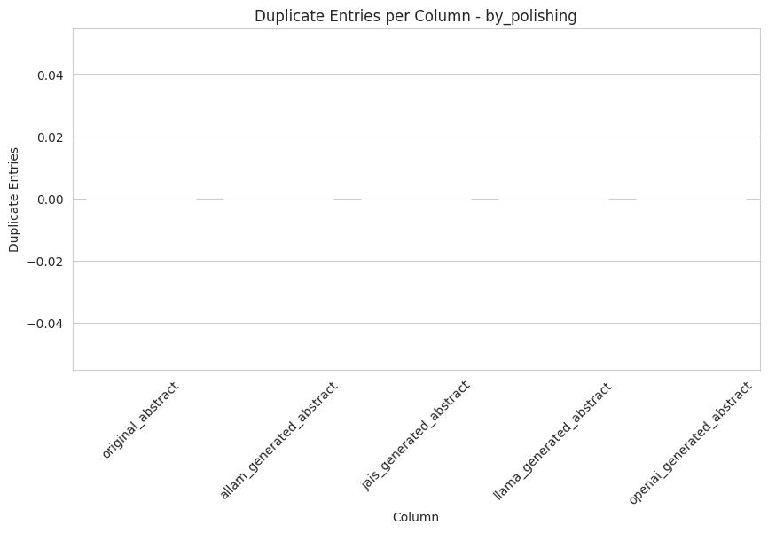

Analysis of Split: from_title

Dataset Structure (Columns)
Column Name | Data Type
original_abstract | Value('string')
allam_generated_abstract | Value('string')
jais_generated_abstract | Value('string')
llama_generated_abstract | Value('string')
openai_generated_abstract | Value('string')

Target Variable Distribution
Class | Count | Percentage
Human-written | 2963 | 20.0%
AI-generated | 11852 | 80.0%

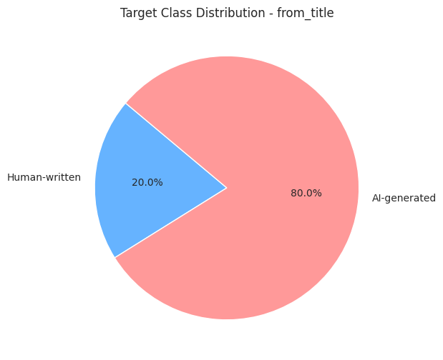

No missing values detected in this split.

Duplicates Analysis
Column | Duplicate Entries
original_abstract | 0
allam_generated_abstract | 0
jais_generated_abstract | 0
llama_generated_abstract | 0
openai_generated_abstract | 0

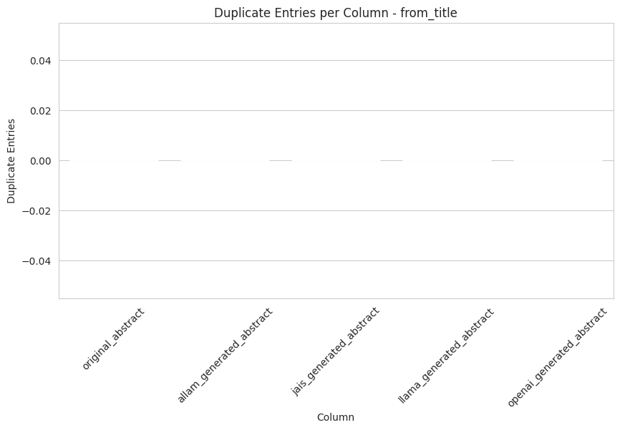

Analysis of Split: from_title_and_content

Dataset Structure (Columns)
Column Name | Data Type
original_abstract | Value('string')
allam_generated_abstract | Value('string')
jais_generated_abstract | Value('string')
llama_generated_abstract | Value('string')
openai_generated_abstract | Value('string')

Target Variable Distribution
Class | Count | Percentage
Human-written | 2574 | 20.0%
AI-generated | 10296 | 80.0%

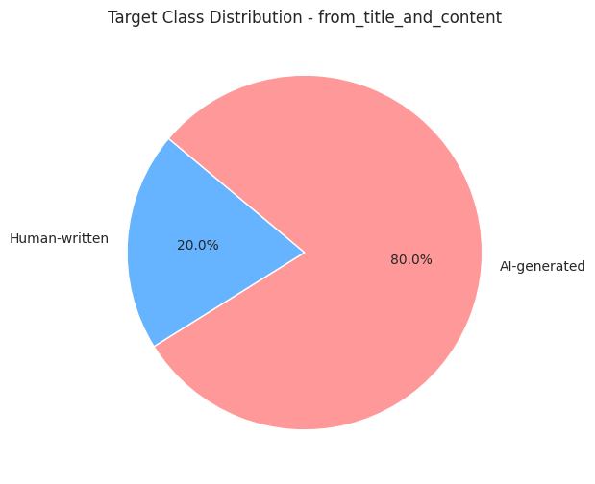

No missing values detected in this split.

Duplicates Analysis
Column | Duplicate Entries
original_abstract | 0
allam_generated_abstract | 0
jais_generated_abstract | 3
llama_generated_abstract | 0
openai_generated_abstract | 0

